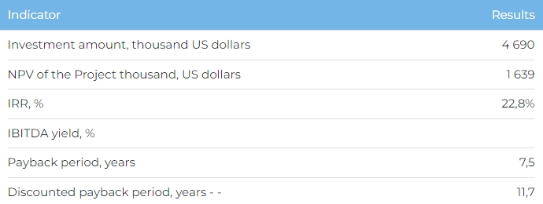
Services
The main target audience of the hotel complex are the inhabitants and guests of Almaty and Almaty Oblast, as well as tourists from foreign countries. At full design capacity the room stock of the complex will amount to 45 guest houses. Annually, it is planned to provide about 10 thousand room-nights.
Project
The Project envisages the construction of the Tau Rakhat hotel complex on a land plot of 5 ha in the Rakhat Rural District, in Almaty Oblast’s Yenbekshikazakh District, 3.5 km from the village of Rakhat. The location is attractive for year-round tourist services, including accommodation in guest homes, swimming pool, bathhouse, cafe, restaurant, etc. In case of need for working capital, the Initiator has the possibility to sell a certain number of cottages, which contributes to the financial sustainability of the Project. Current Project status:
- A land plot of 5 ha site has been purchased and discussions are being held with the Almaty Oblast Akimat to obtain an adjacent plot of 2.5 ha as an in-kind grant;
- An agreement has been reached with Bionic Forms LLP, specializing in cottage village construction.
Company
The Project Initiator is Tau Rakhat Samaly LLP, which was created to implement the Project.
Market
- In 2022, the volume of tourism industry in Kazakhstan increased by 17.9% and amounted to 11.2 billion USD, with a compounded annual growth rate of 20.6% during 2020-2022. According to Marketline forecasts, by 2027 the volume of the tourism market in Kazakhstan in value terms will be 16.7 billion USD, an increase of 49,1% compared to 2022. Compounded annual growth rate of the industry over the period 2022-2027 is projected to be 8.3%.
- According to Kazakh Tourism, in 2021, Kazakhstan ranked 66th out of 117 countries in the World Travel and Tourism Development Index, ahead of Montenegro (67), Morocco (71), Kyrgyzstan (90).
- Total income generated by tourist accommodation in Almaty Oblast and Almaty was 136 million USD. In 2022, 30% of all tourists in Kazakhstan stayed at tourist accommodation in Almaty and Almaty Oblast, which generated roughly 34% of total accommodation income.
What is the attractiveness of the project?
- Attractive location. As a transport and logistics hub linking Europe and China, Almaty Oblast also has immense tourism potential thanks to its unique natural characteristics.
- Introduction of innovation. Access to resources, the use of innovative technology in the hotel industry and implementation of new hotel management techniques will help maintain sustained long-term development, increase hotel market competitiveness, and create conditions for expanding the scope of services offered.
- State support. The government actively supports tourism in Kazakhstan, compensating costs to purchase equipment and build tourist facilities
Investment proposal
The Project requires investment of 4,690 thousand USD (at the rate of 449.2 tenge), of which:
- 70% (3,283 thousand USD) - debt financing subject to collateral;
- 30% (1,407 thousand USD) - investor participation.
The proposed financing structure and state support measures are indicative. The final financing structure and Project interests will be determined based on the results of negotiations with the investor.
